Terraform Challenge 1

1. Create an EC2 Instance on AWS Cloud using the below-mentioned ubuntu AMI and instance_type. Or, (You can use of your choice as well) ami = "ami-0461b1436c9b3c1a3" instance_type = "t2.micro".
2. Install a web server on the same EC2 Instance. The web server should listen on port 8080..
3. Create a Docker-compose file for the project:https://github.com/betawins/cricbuzz-docker-hello-world.gitand point it to port 8000..
4. Make the web server point to the above service so that 8080 returns the response from the Docker service..
5. Configure to Save the Logs in the location /var/log/cb.log.
6. Write the Log rotate configuration for the above file.

Task 1 – Create a Ec2 Instance
Step 1.1 — Create main.tf
cd ~/terraform-cricbuzz
vi main.tf – Add code in it
terraform {
required_version = ">= 1.5.0"

required_providers {
aws = {
source = "hashicorp/aws"
version = "~> 6.0"
}
}
}

provider "aws" {
region = "ap-south-1"
}

# Get the default VPC
data "aws_vpc" "default" {
default = true
}

# Get the default subnet in ap-south-1b
data "aws_subnet" "default" {
filter {
name = "subnet-id"
values = ["subnet-0a5553bb08e975b03"]
}
}

# Security Group
resource "aws_security_group" "cricbuzz_sg" {
name = "cricbuzz-challenge-sg"
description = "Security group for Cricbuzz Terraform challenge"
vpc_id = data.aws_vpc.default.id

# SSH access
ingress {
description = "SSH"
from_port = 22
to_port = 22
protocol = "tcp"
cidr_blocks = ["0.0.0.0/0"]
}

# Application access
ingress {
description = "Application"
from_port = 8080
to_port = 8080
protocol = "tcp"
cidr_blocks = ["0.0.0.0/0"]
}

# Outbound traffic
egress {
from_port = 0
to_port = 0
protocol = "-1"
cidr_blocks = ["0.0.0.0/0"]
}

tags = {
Name = "cricbuzz-challenge-sg"
}
}

# EC2 Instance
resource "aws_instance" "cricbuzz" {
ami = "ami-0461b1436c9b3c1a3"
instance_type = "t2.micro"

subnet_id = data.aws_subnet.default.id

vpc_security_group_ids = [
aws_security_group.cricbuzz_sg.id
]

associate_public_ip_address = true

tags = {
Name = "cricbuzz-terraform"
}
}
}Step 1.2 — Format the Terraform code
terraform fmt
Expected:
main.tf
Step 1.3 — Initialize Terraform
terraform init
This downloads the AWS provider.
At the end, you should see something similar to:
Terraform has been successfully initialized!

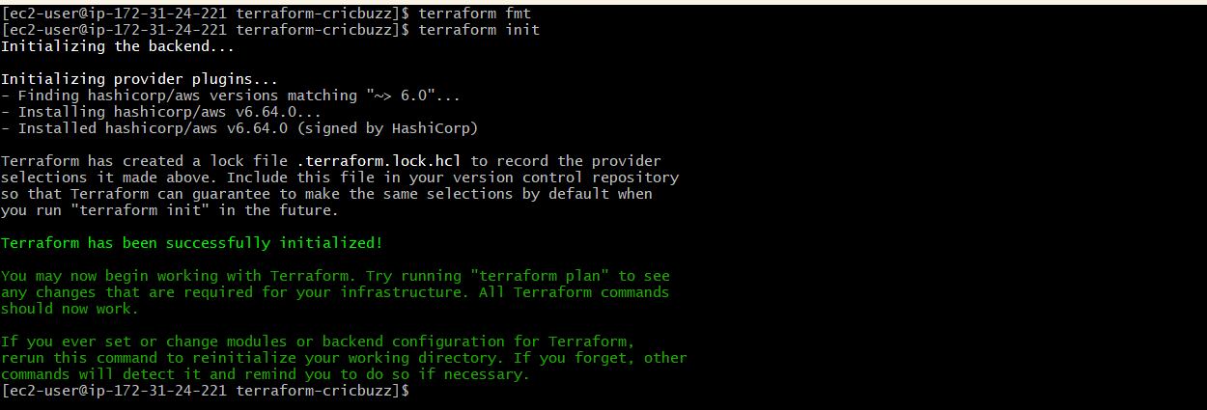
Step 1.4 — Validate
terraform validate
Expected:
Success! The configuration is valid.
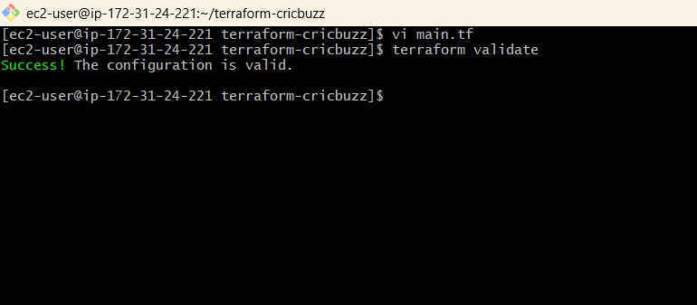
Then:
terraform plan
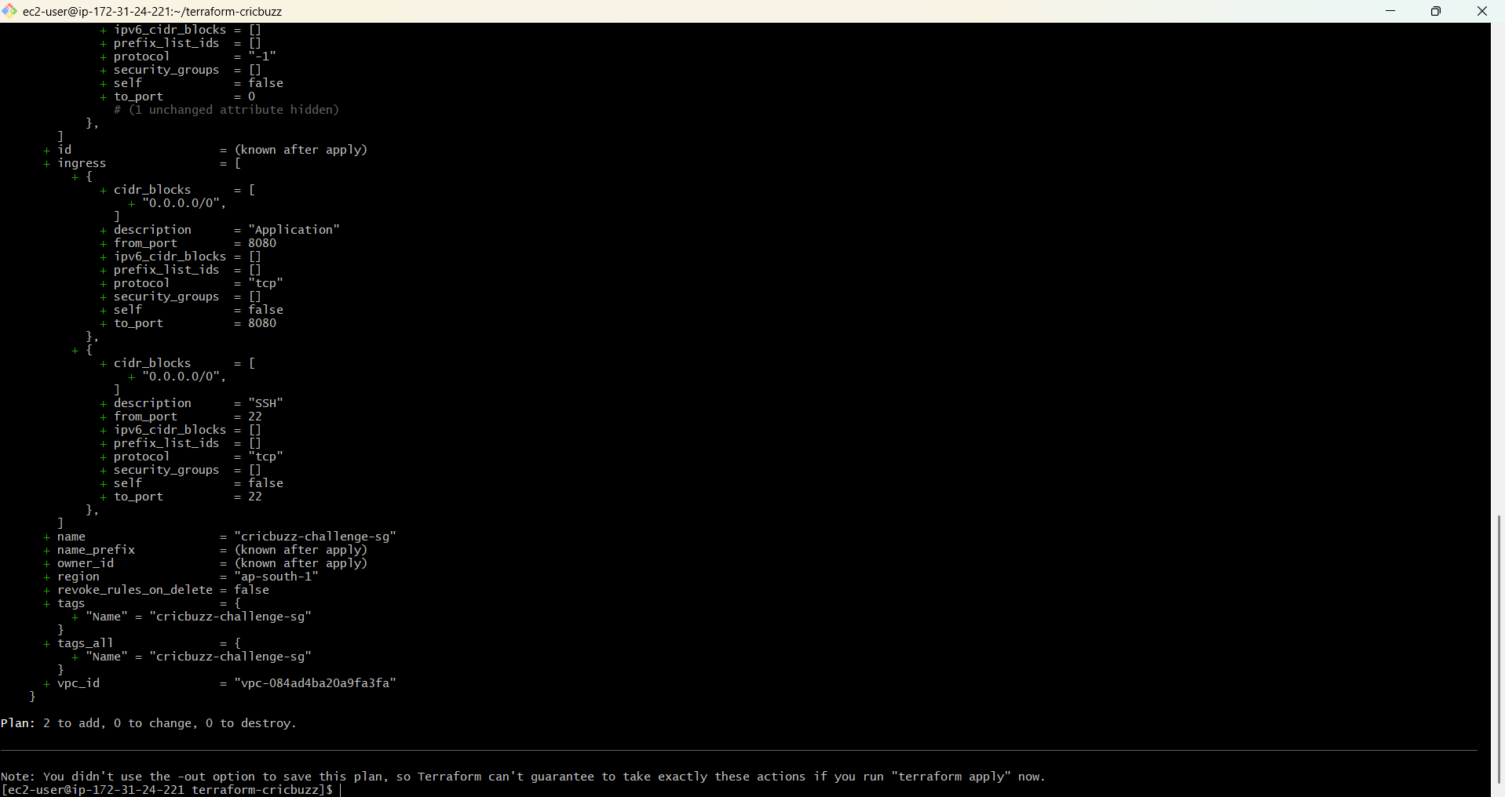
Apply the Terraform configuration
Run:
terraform apply
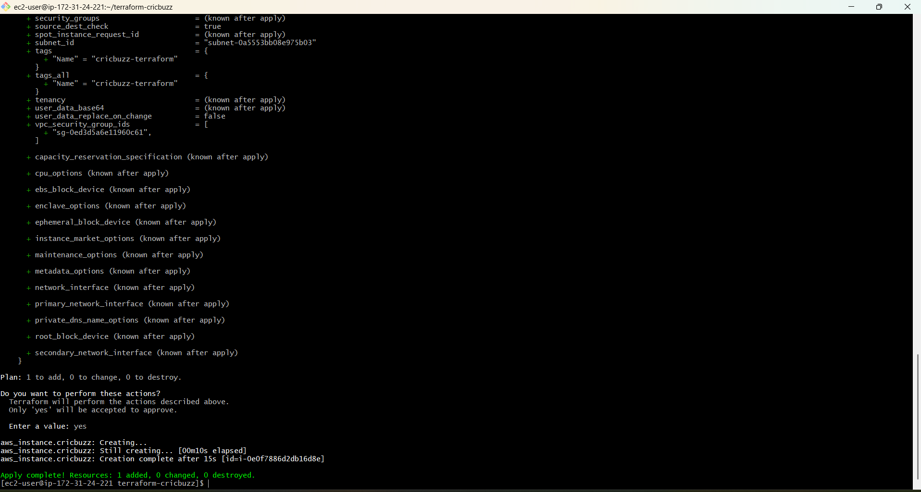
Verification
Run:
terraform state list
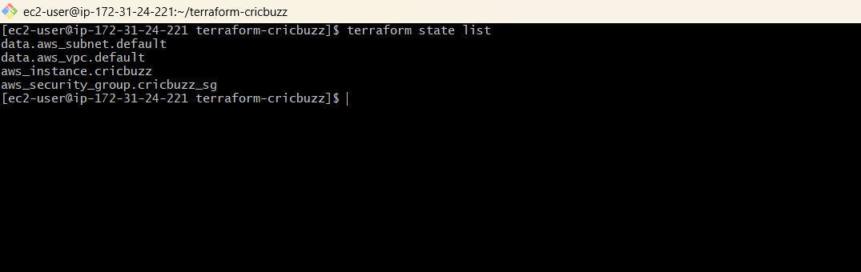
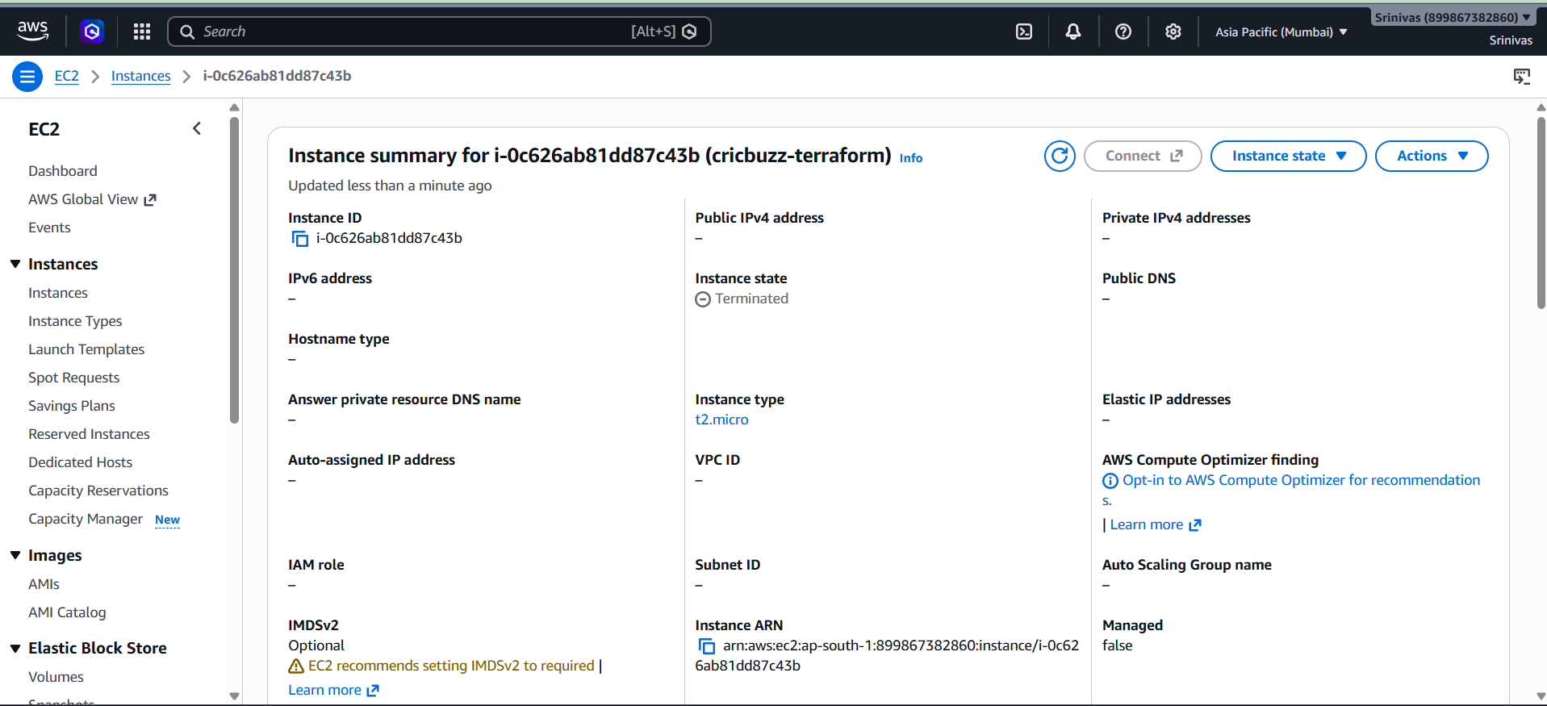

Task 2 — Install Web Server
Objective
Install Nginx on the newly created Ubuntu EC2 and configure it to listen on:
Port: 8080
At the end:
Internet
|
| :8080
↓
Nginx
|
↓
Response
For this task, we'll use Terraform user_data so Nginx is installed automatically when the EC2 is created/updated.
Step 2.1 — Create user_data.sh
From your Terraform project:
cd ~/terraform-cricbuzz
Create the file:
vi user_data.sh
Add Code : #!/bin/bash

set -e

# Update package information
apt-get update -y

# Install Nginx
apt-get install -y nginx

# Enable Nginx at system startup
systemctl enable nginx

# Start Nginx
systemctl start nginx

# Remove the default Nginx site
rm -f /etc/nginx/sites-enabled/default

# Create Cricbuzz Nginx configuration
cat > /etc/nginx/sites-available/cricbuzz <<'EOF'
server {
listen 8080;
listen [::]:8080;

server_name _;

location / {
return 200 "Cricbuzz Terraform Challenge - Nginx is running on port 8080\n";
add_header Content-Type text/plain;
}
}
EOF

# Enable the Cricbuzz site
ln -sf /etc/nginx/sites-available/cricbuzz \
/etc/nginx/sites-enabled/cricbuzz

# Test Nginx configuration
nginx -t

# Restart Nginx with the new configuration
systemctl restart nginx

echo "Nginx installation and configuration completed successfully."
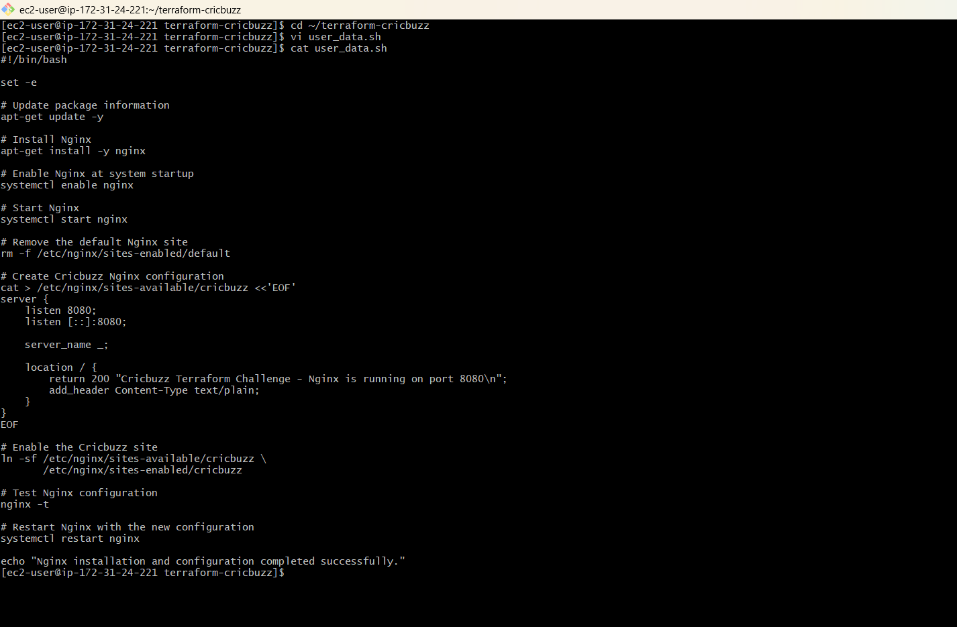

Make it executable:
chmod +x user_data.sh
Step 2.2 — Update main.tf
Because we're now using user_data, replace the entire main.tf with:
terraform {
required_version = ">= 1.5.0"

required_providers {
aws = {
source = "hashicorp/aws"
version = "~> 6.0"
}
}
}

provider "aws" {
region = "ap-south-1"
}

# Get the default VPC
data "aws_vpc" "default" {
default = true
}

# Get the default subnet in ap-south-1b
data "aws_subnet" "default" {
filter {
name = "subnet-id"
values = ["subnet-0a5553bb08e975b03"]
}
}

# Security Group
resource "aws_security_group" "cricbuzz_sg" {
name = "cricbuzz-challenge-sg"
description = "Security group for Cricbuzz Terraform challenge"
vpc_id = data.aws_vpc.default.id

# SSH access
ingress {
description = "SSH"
from_port = 22
to_port = 22
protocol = "tcp"
cidr_blocks = ["0.0.0.0/0"]
}

# Application access
ingress {
description = "Application"
from_port = 8080
to_port = 8080
protocol = "tcp"
cidr_blocks = ["0.0.0.0/0"]
}

# Outbound traffic
egress {
from_port = 0
to_port = 0
protocol = "-1"
cidr_blocks = ["0.0.0.0/0"]
}

tags = {
Name = "cricbuzz-challenge-sg"
}
}

# EC2 Instance
resource "aws_instance" "cricbuzz" {
ami = "ami-0461b1436c9b3c1a3"
instance_type = "t2.micro"

subnet_id = data.aws_subnet.default.id

vpc_security_group_ids = [
aws_security_group.cricbuzz_sg.id
]

associate_public_ip_address = true

user_data = file("${path.module}/user_data.sh")

user_data_replace_on_change = true

tags = {
Name = "cricbuzz-terraform"
}
}
Step 2.3 — Format and validate
Run:
terraform fmt
Then:
terraform validate
Expected:
Success! The configuration is valid.
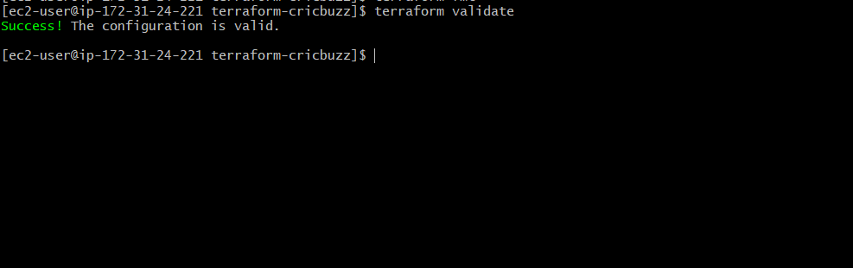
Step 2.4 — Check the plan
Run:
terraform plan
Because we're adding user_data to the existing EC2, Terraform should show that the instance needs to be replaced.
You will likely see:
-/+ aws_instance.cricbuzz
The important point is:
-/+ = destroy and recreate
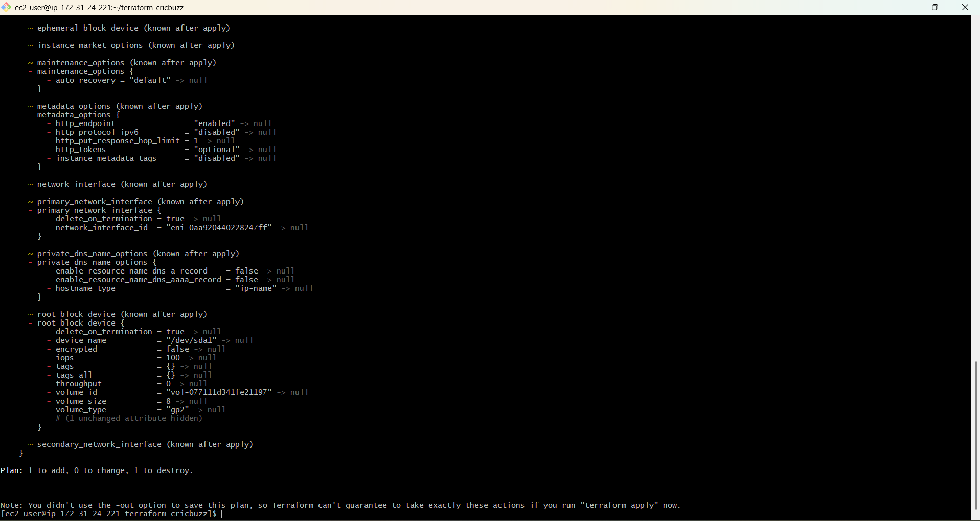
Run:
terraform apply
When prompted:
Do you want to perform these actions?
enter:
yes

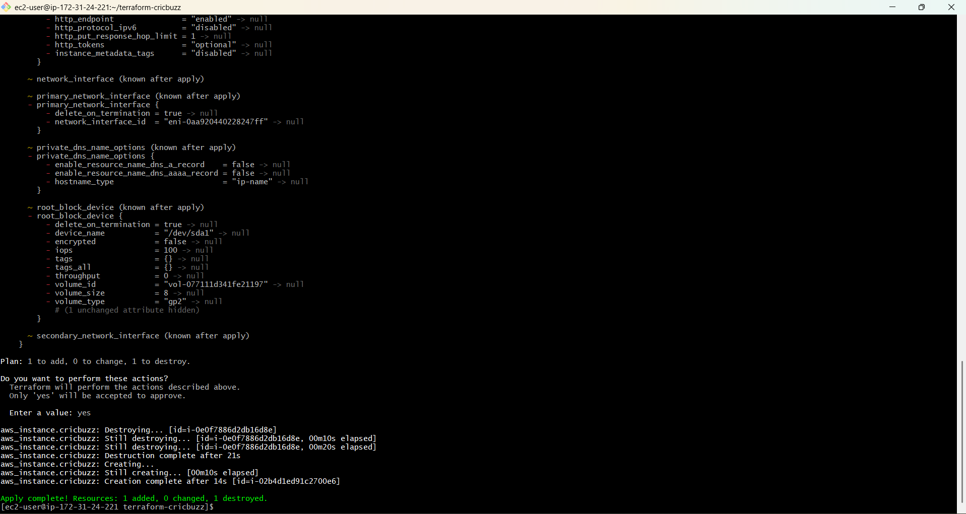
After apply finishes
Run:
terraform state list
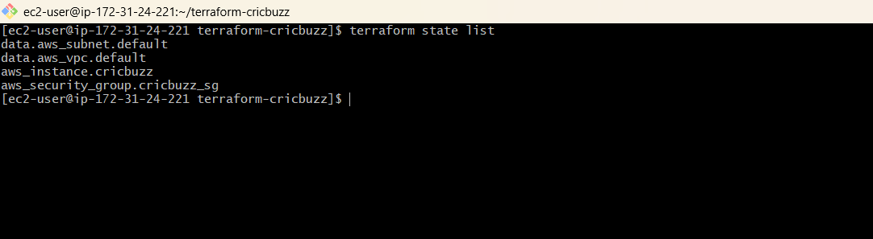
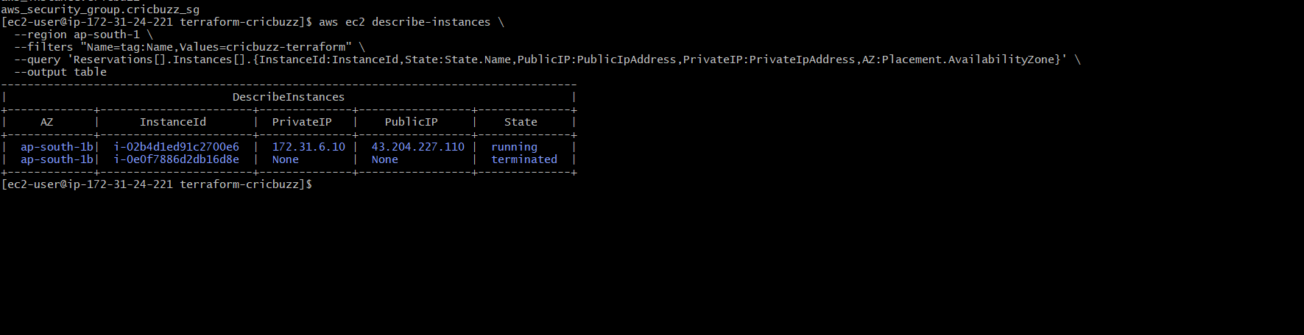
Verify Nginx
Step 2.5 — SSH into the new EC2
From your Terraform server, run:
ssh -i ~/krishna7.pem ubuntu@43.204.227.110
Once you're inside, run these four commands:
sudo systemctl status nginx --no-pager
sudo ss -lntp | grep 8080
curl http://localhost:8080
sudo nginx -t
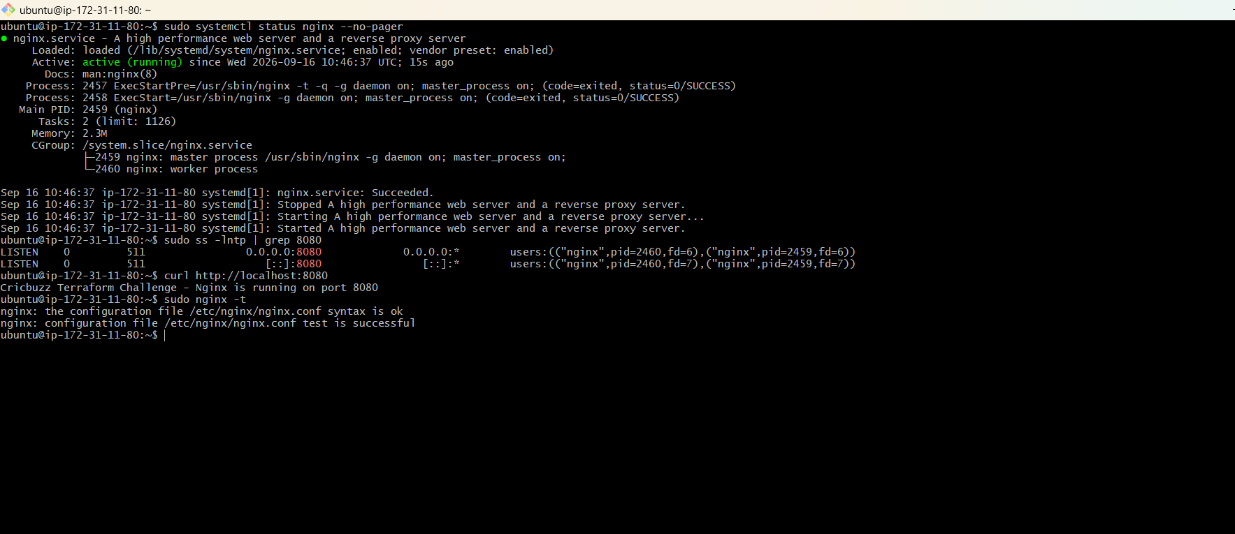

Task 3 — Create Docker Compose
Objective
We need to:
- Install Docker
- Install Docker Compose
- Create a Compose file for the Cricbuzz project
- Run the service on port 8000

Step 3.1 — Update user_data.sh
Because the EC2 is already running, changing user_data.sh alone will not execute it again unless Terraform replaces the instance.
For the assignment, we'll update the Terraform configuration so the new complete bootstrap script installs both Nginx and Docker.
First, exit the EC2:
Exit
You should return to:
[ec2-user@... terraform-cricbuzz]$
Now replace the entire user_data.sh with:
#!/bin/bash

set -e

echo "===== Starting Cricbuzz setup ====="

# Update packages
apt-get update -y

# Install required packages
apt-get install -y \
nginx \
docker.io \
docker-compose-plugin \
curl

# Enable and start Docker
systemctl enable docker
systemctl start docker

# Enable and start Nginx
systemctl enable nginx
systemctl start nginx

# Create application directory
mkdir -p /opt/cricbuzz

# Create Docker Compose file
cat > /opt/cricbuzz/compose.yaml <<'EOF'
services:
cricbuzz:
image: ghcr.io/infrastructure-as-code/hello-world:latest
container_name: cricbuzz
restart: unless-stopped
ports:
- "8000:8080"
EOF

# Start Cricbuzz application
cd /opt/cricbuzz
docker compose up -d

# Wait for application to start
sleep 10

# Configure Nginx
rm -f /etc/nginx/sites-enabled/default

cat > /etc/nginx/sites-available/cricbuzz <<'EOF'
server {
listen 8080;
listen [::]:8080;

server_name _;

location / {
proxy_pass http://127.0.0.1:8000;

proxy_http_version 1.1;

proxy_set_header Host $host;
proxy_set_header X-Real-IP $remote_addr;
proxy_set_header X-Forwarded-For $proxy_add_x_forwarded_for;
proxy_set_header X-Forwarded-Proto $scheme;
}
}
EOF

# Enable Nginx configuration
ln -sf /etc/nginx/sites-available/cricbuzz \
/etc/nginx/sites-enabled/cricbuzz

# Create log file
touch /var/log/cb.log

# Configure Nginx logging
cat > /etc/nginx/conf.d/cricbuzz-logging.conf <<'EOF'
log_format cricbuzz '$remote_addr - $remote_user [$time_local] '
'"$request" $status $body_bytes_sent '
'"$http_referer" "$http_user_agent"';
EOF

# Test Nginx configuration
nginx -t

# Restart Nginx
systemctl restart nginx

# Configure logrotate
cat > /etc/logrotate.d/cricbuzz <<'EOF'
/var/log/cb.log {
daily
rotate 7
missingok
notifempty
compress
delaycompress
copytruncate
}
EOF

echo "===== Cricbuzz setup completed ====="
Step 3.2 — Format and validate
Run these commands one at a time:
terraform fmt
Then:
terraform validate
Expected:
Success! The configuration is valid.
Then:
terraform plan
Then
Terraform apply :
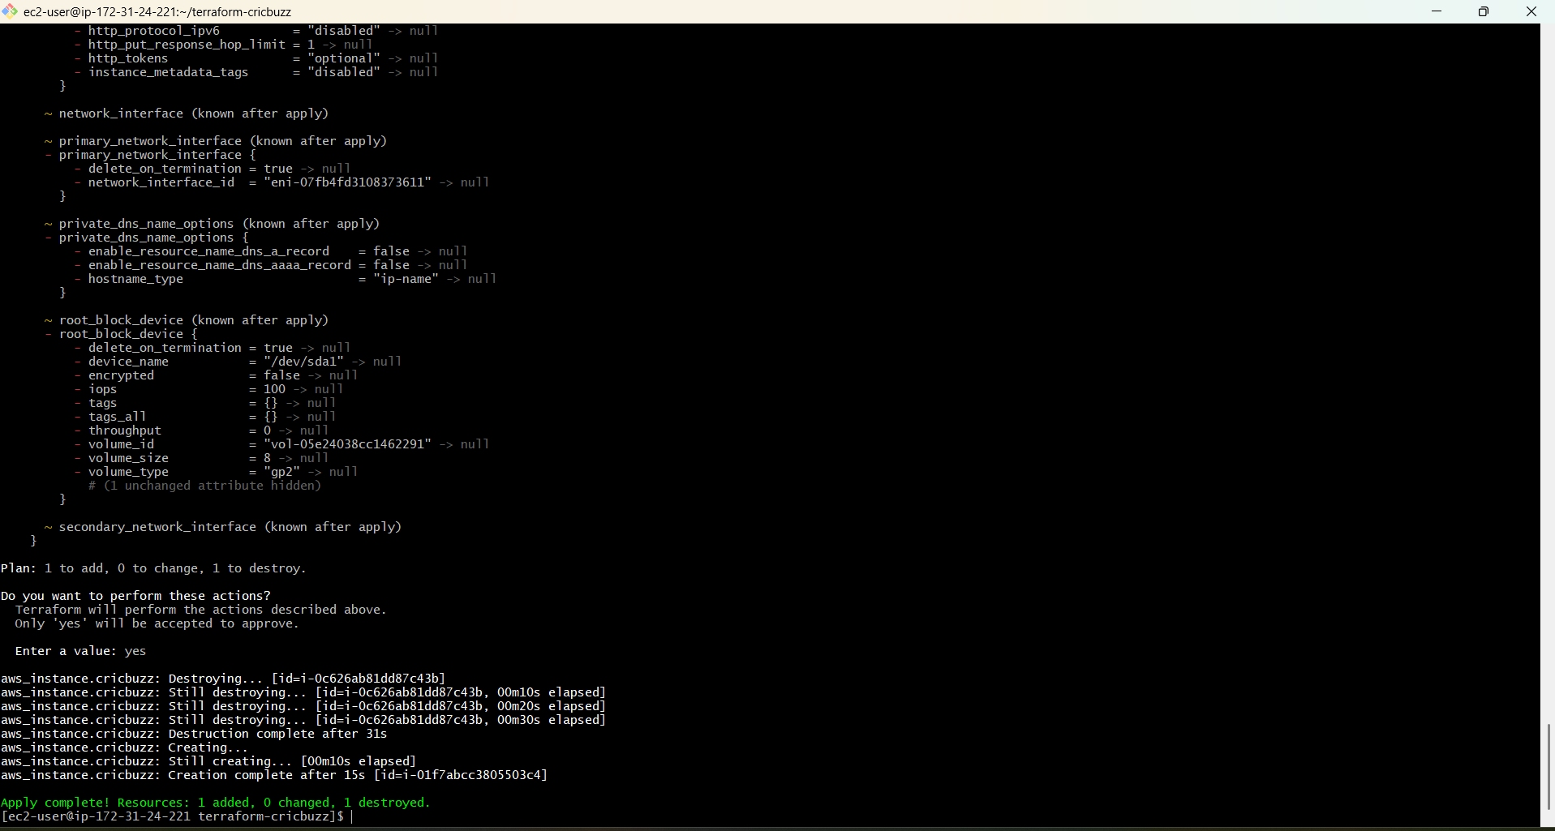
Task 3 — Verify Docker & Docker Compose
First get the new public IP:
aws ec2 describe-instances \
--region ap-south-1 \
--filters "Name=tag:Name,Values=cricbuzz-terraform" \
--query 'Reservations[].Instances[?State.Name==`running`].{InstanceId:InstanceId,PublicIP:PublicIpAddress,PrivateIP:PrivateIpAddress,State:State.Name}' \
--output table
Then run:
ssh -i ~/krishna7.pem ubuntu@13.235.48.124
Once logged in, run:
sudo systemctl status docker --no-pager

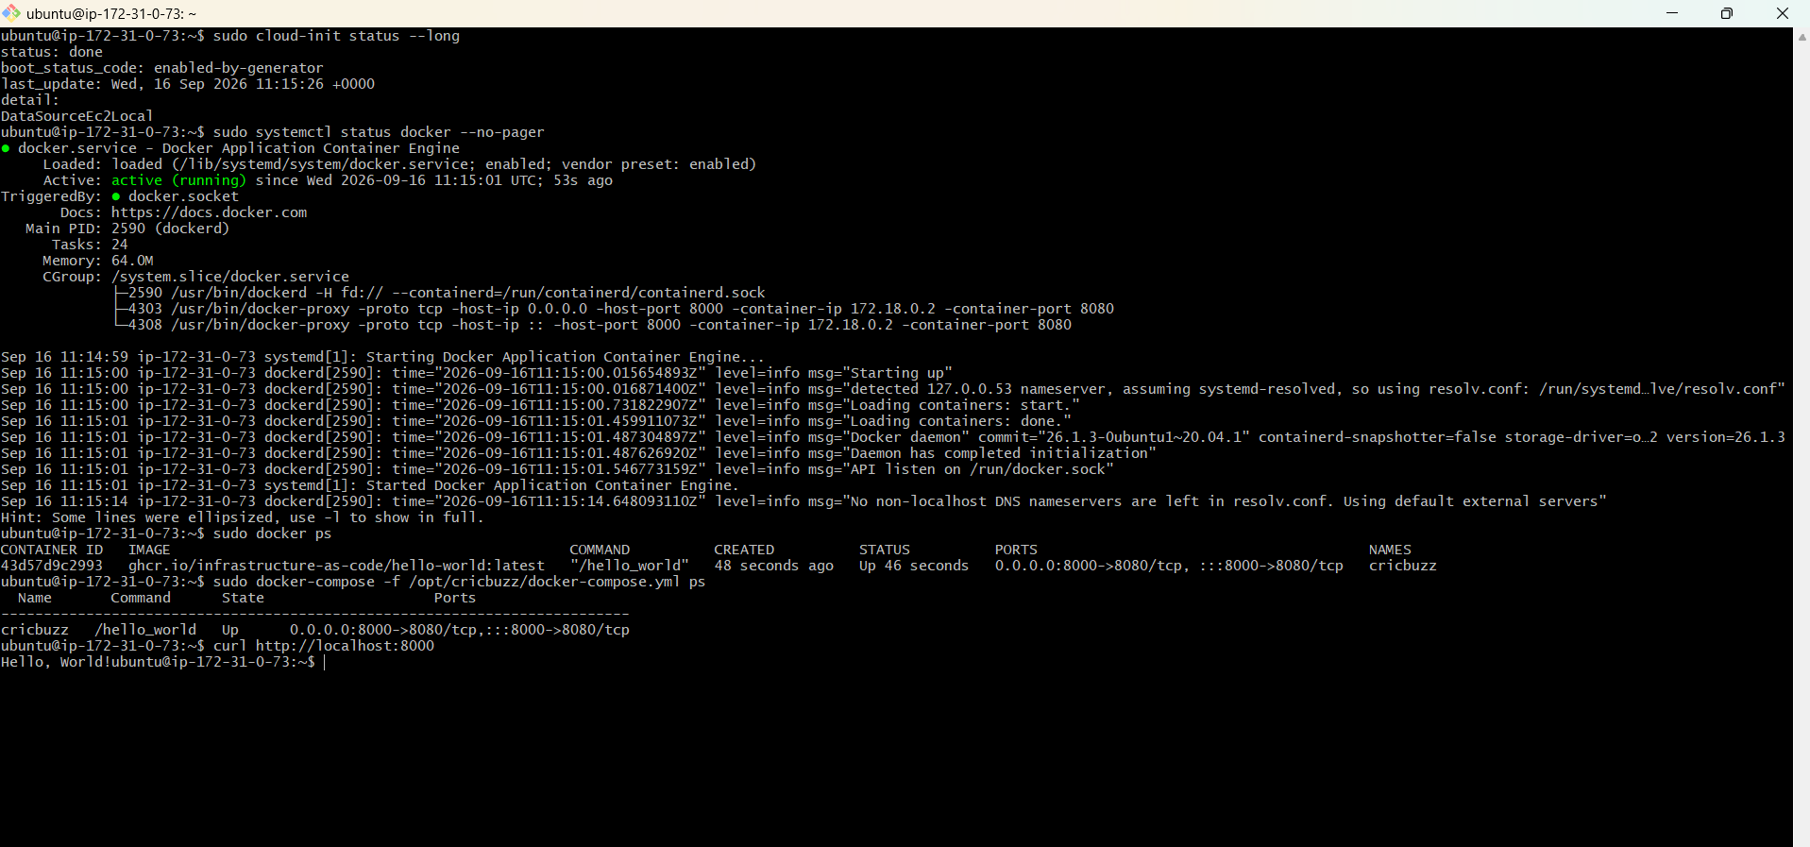

Task 4 — Configure Nginx Reverse Proxy
Task 4 — Configure Nginx Reverse Proxy
Now we need to prove that port 8080 on the EC2 forwards requests to the Docker application on port 8000.
Your user_data.sh already contains the Nginx configuration, so don't manually modify anything yet.
Step 16 — Check Nginx
Run:
sudo systemctl status nginx --no-pager
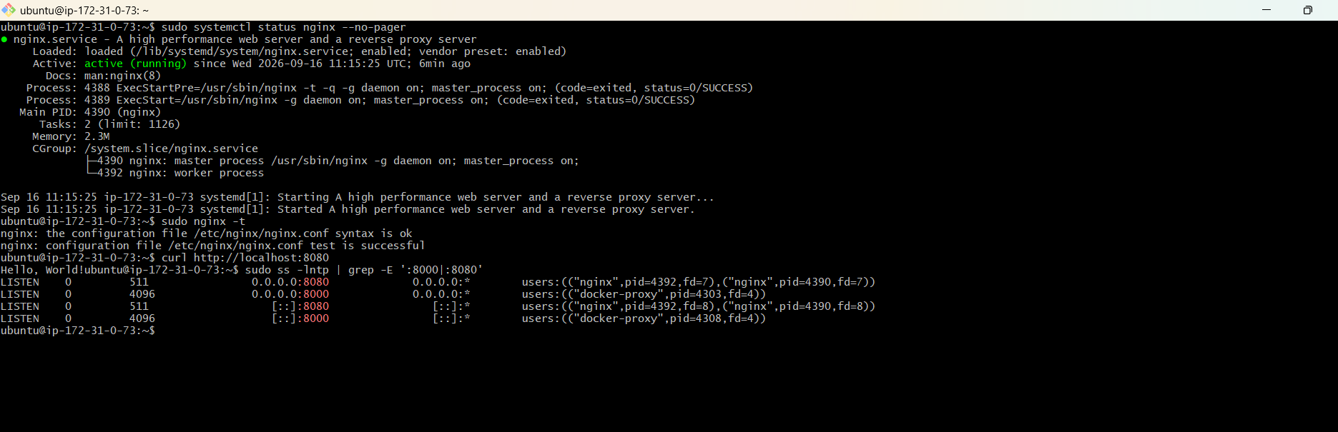

Task 5 — Configure /var/log/cb.log
Your user_data.sh already contains the logging configuration, so now we'll verify it rather than changing anything.
Run these commands:
sudo ls -l /var/log/cb.log
Then generate a request:
curl http://localhost:8080
Then check the log:
sudo tail -20 /var/log/cb.log
Finally check the Nginx configuration for the log:
sudo grep -R "cb.log" /etc/nginx/sites-enabled/
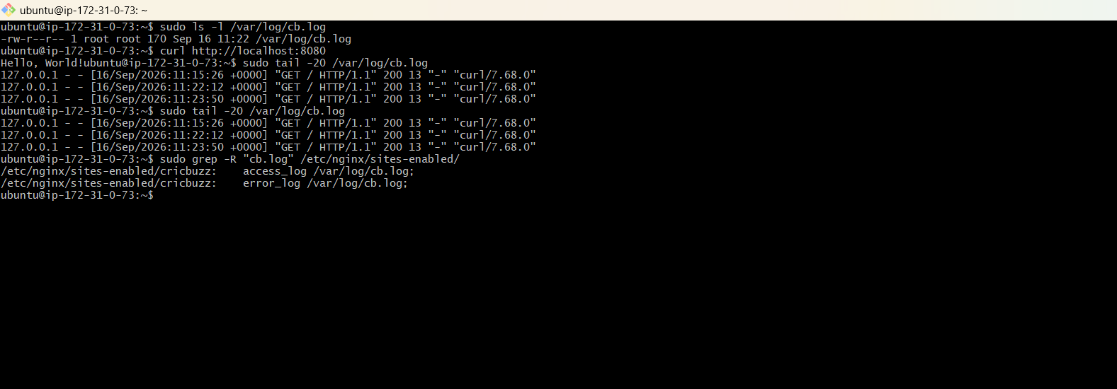

Task 6 — Configure and Verify Logrotate
Replace the entire user_data.sh with:
#!/bin/bash

set -e

echo "===== Starting Cricbuzz Terraform Challenge setup ====="

# --------------------------------------------------
# 1. Update system packages
# --------------------------------------------------

apt-get update -y

# --------------------------------------------------
# 2. Install required packages
# --------------------------------------------------

apt-get install -y \
nginx \
docker.io \
docker-compose \
curl

# --------------------------------------------------
# 3. Enable and start Docker
# --------------------------------------------------

systemctl enable docker
systemctl start docker

# --------------------------------------------------
# 4. Enable and start Nginx
# --------------------------------------------------

systemctl enable nginx
systemctl start nginx

# --------------------------------------------------
# 5. Create Cricbuzz application directory
# --------------------------------------------------

mkdir -p /opt/cricbuzz

cd /opt/cricbuzz

# --------------------------------------------------
# 6. Create Docker Compose file
# --------------------------------------------------

cat > /opt/cricbuzz/docker-compose.yml <<'EOF'
version: "3.3"

services:

cricbuzz:
image: ghcr.io/infrastructure-as-code/hello-world:latest
container_name: cricbuzz
restart: unless-stopped

ports:
- "8000:8080"
EOF

# --------------------------------------------------
# 7. Start Cricbuzz Docker service
# --------------------------------------------------

cd /opt/cricbuzz

docker-compose up -d

# --------------------------------------------------
# 8. Wait for Docker service
# --------------------------------------------------

sleep 10

# --------------------------------------------------
# 9. Configure Nginx
# --------------------------------------------------

rm -f /etc/nginx/sites-enabled/default

cat > /etc/nginx/sites-available/cricbuzz <<'EOF'
server {

listen 8080;
listen [::]:8080;

server_name _;

access_log /var/log/cb.log;
error_log /var/log/cb.log;

location / {

proxy_pass http://127.0.0.1:8000;

proxy_http_version 1.1;

proxy_set_header Host $host;
proxy_set_header X-Real-IP $remote_addr;
proxy_set_header X-Forwarded-For $proxy_add_x_forwarded_for;
proxy_set_header X-Forwarded-Proto $scheme;
}
}
EOF

# --------------------------------------------------
# 10. Enable Cricbuzz Nginx configuration
# --------------------------------------------------

ln -sf /etc/nginx/sites-available/cricbuzz \
/etc/nginx/sites-enabled/cricbuzz

# --------------------------------------------------
# 11. Create application log file
# --------------------------------------------------

touch /var/log/cb.log

# --------------------------------------------------
# 12. Test Nginx configuration
# --------------------------------------------------

nginx -t

# --------------------------------------------------
# 13. Restart Nginx
# --------------------------------------------------

systemctl restart nginx

# --------------------------------------------------
# 14. Configure Logrotate
# --------------------------------------------------

cat > /etc/logrotate.d/cricbuzz <<'EOF'
/var/log/cb.log {
daily
rotate 7
missingok
notifempty
compress
delaycompress
copytruncate
su root root
}
EOF

# --------------------------------------------------
# 15. Final verification
# --------------------------------------------------

echo "===== Docker status ====="
systemctl status docker --no-pager

echo "===== Docker Compose version ====="
docker-compose --version

echo "===== Docker containers ====="
docker ps

echo "===== Docker service test ====="
curl http://127.0.0.1:8000 || true

echo "===== Nginx status ====="
systemctl status nginx --no-pager

echo "===== Nginx proxy test ====="
curl http://127.0.0.1:8080 || true

echo "===== Logrotate configuration ====="
cat /etc/logrotate.d/cricbuzz

echo "===== Setup completed ====="
Validate
Run:
terraform fmt
Then:
terraform validate
Then:
terraform plan
then
Terraform apply
Apply complete! Resources: 1 added, 0 changed, 1 destroyed.
The new EC2 is:
Instance ID: i-04e72ad0885c0c0d1
Now we need to get its new public IP.
Step 20 — Get the new instance IP
Run this from the Terraform server:
aws ec2 describe-instances \
--region ap-south-1 \
--instance-ids i-04e72ad0885c0c0d1 \
--query 'Reservations[].Instances[].{InstanceId:InstanceId,State:State.Name,PublicIP:PublicIpAddress,PrivateIP:PrivateIpAddress}' \
--output table
Step 21 — SSH into the new instance
Run:
ssh -i ~/krishna7.pem ubuntu@13.204.46.84
After connecting, wait about 30–60 seconds for cloud-init to finish, then run:
sudo cloud-init status --long
Then verify logrotate:
sudo cat /etc/logrotate.d/cricbuzz
Then:
sudo logrotate -d /etc/logrotate.d/cricbuzz
Important
In the debug output, we do not want to see:
error: skipping "/var/log/cb.log"
We should see the configuration being processed with:
su root root
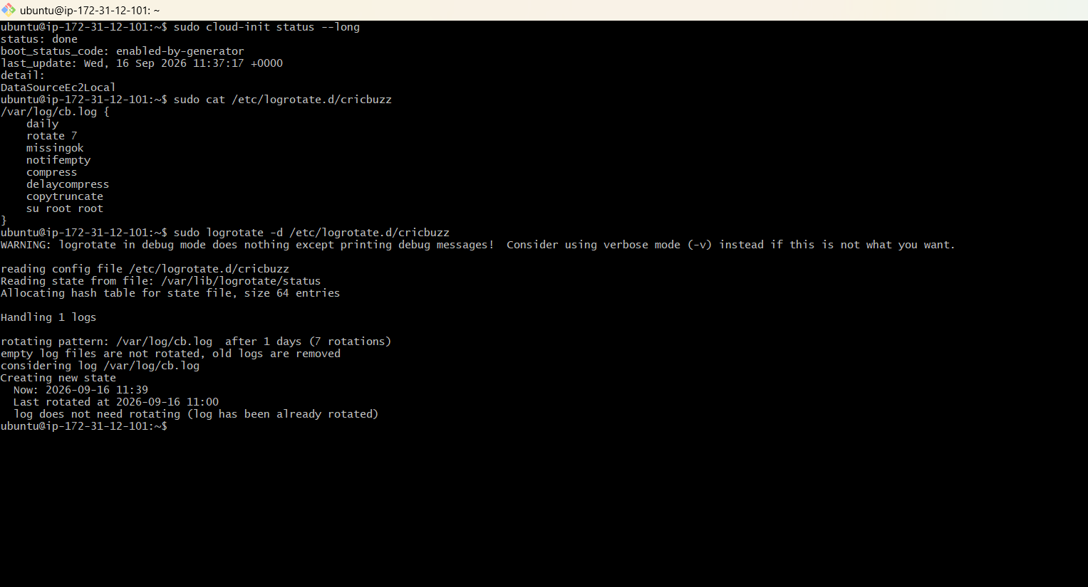
Final verification
Before we declare the challenge completely finished, run these on the current instance:
sudo docker ps
curl http://localhost:8000
curl http://localhost:8080
sudo tail -5 /var/log/cb.log
sudo nginx -t
And finally:
sudo cat /etc/logrotate.d/cricbuzz
